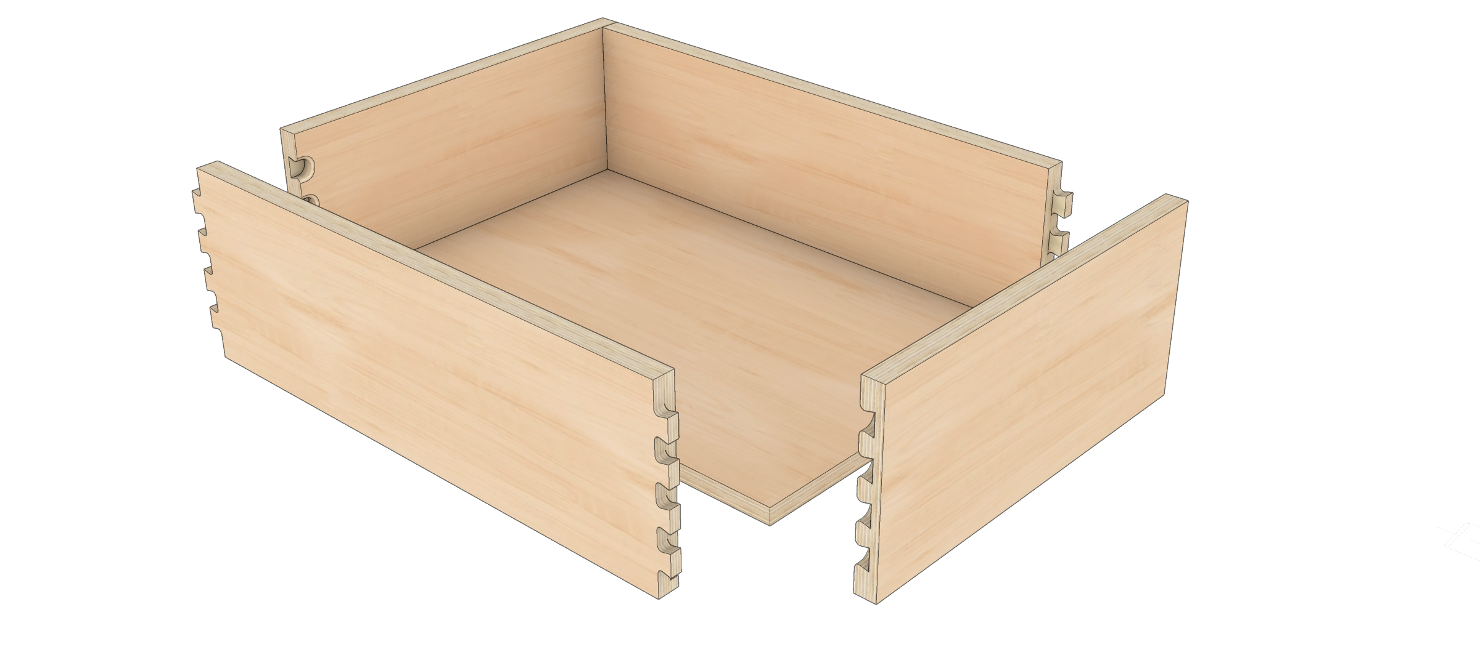**Dovetail Drawer Setup**

**Mozaik’s dovetail setup allows production of dovetail drawers on a flat-bed, nested based CNC Machines. Standard setups (such as Vortex) may be used to fill in the parameters for the tool paths.**

**Vortex Standard Setups**

Currently there are only 2 standard setups. When selected, they fill in the values for the Pin dimensions to accommodate the toolset. Vortex tool company offers 2 insert tooling setups for this system. The 9101 insert which produces a radius tip dovetail pin and the 9282 insert which produces the more traditional “square tip” dovetail pin. The drawer box pictured below on the left was created with the Vortex standard setup 9101 insert and the drawer on the right was created with the 9282 insert setup.

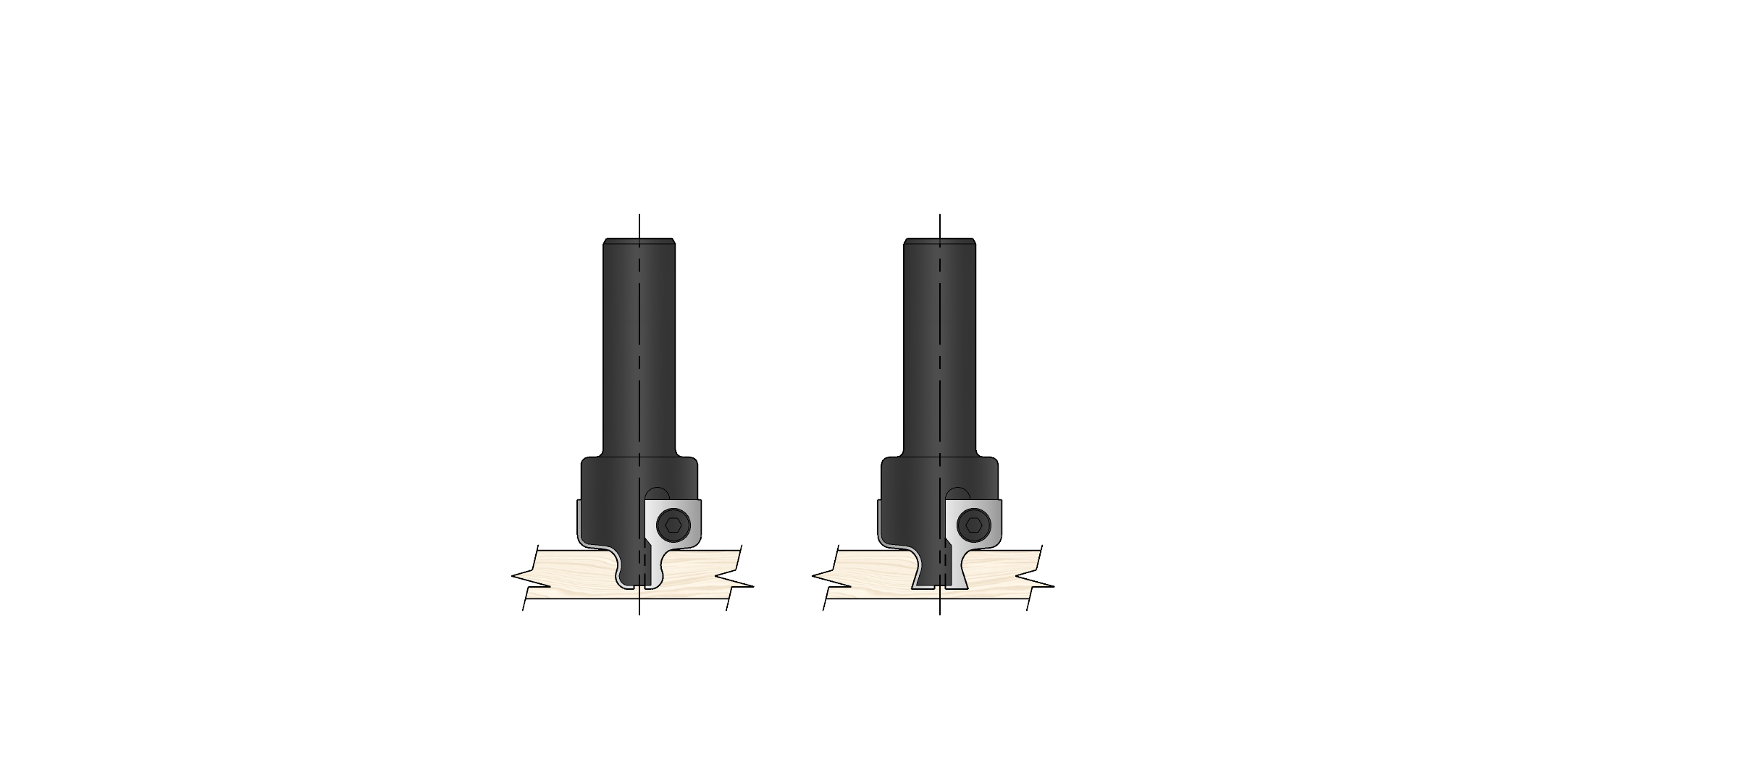

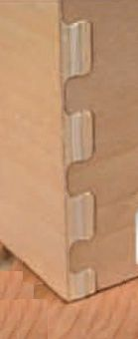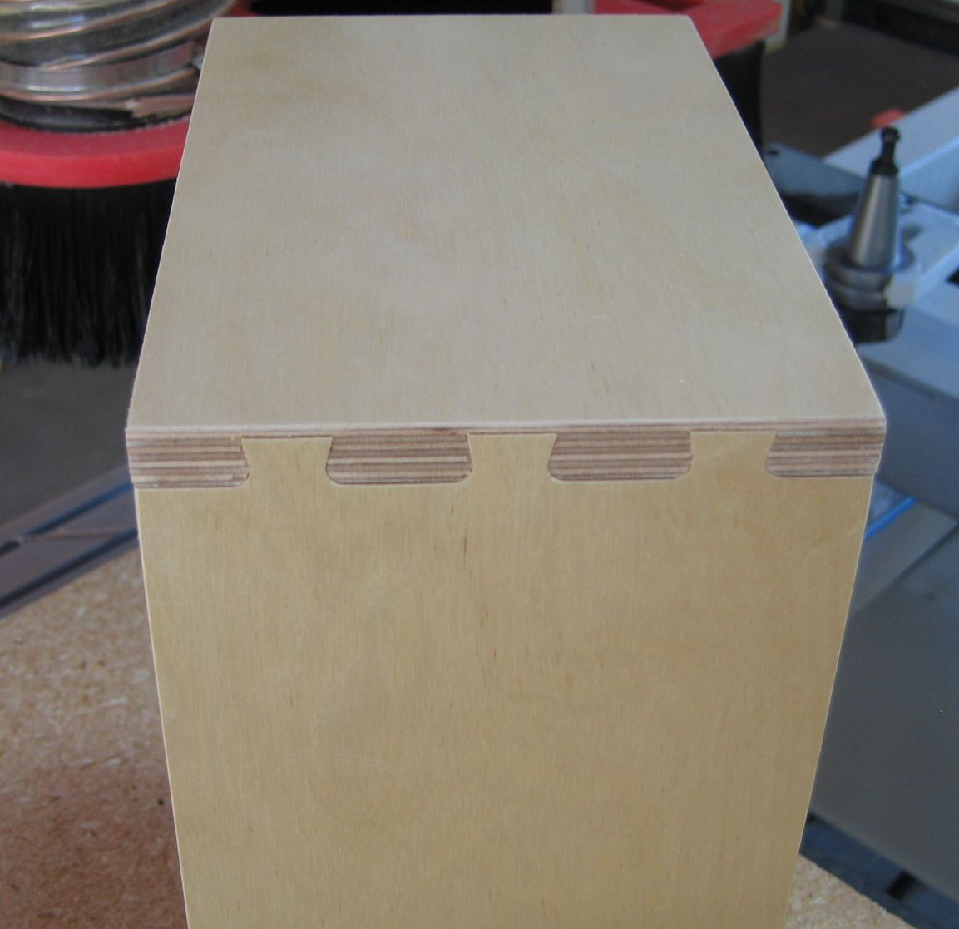

**Vortex 9101 Insert**

**Vortex 9282 Insert**

**Pin Tool Selection**

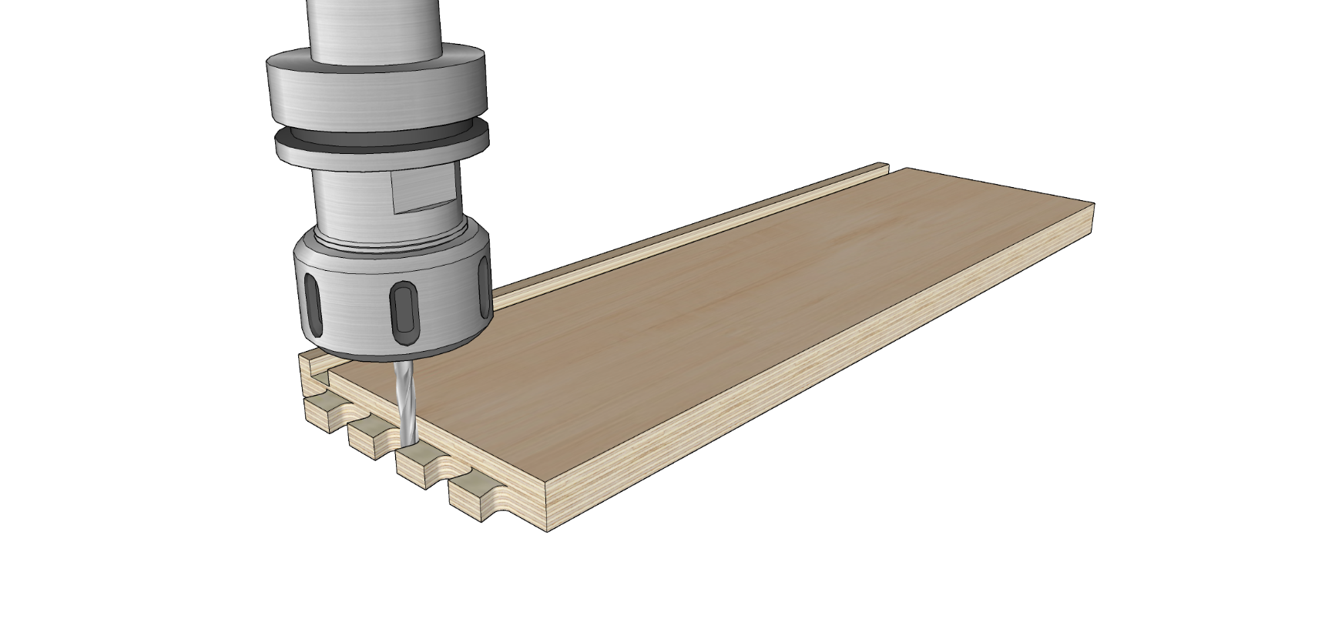Select the tool for the Pin. This tool is typically a 1/4” in diameter. It is recommended that this tool is a compression as it cuts all the way through the material to create the pins.

**Tail Tool Selection**

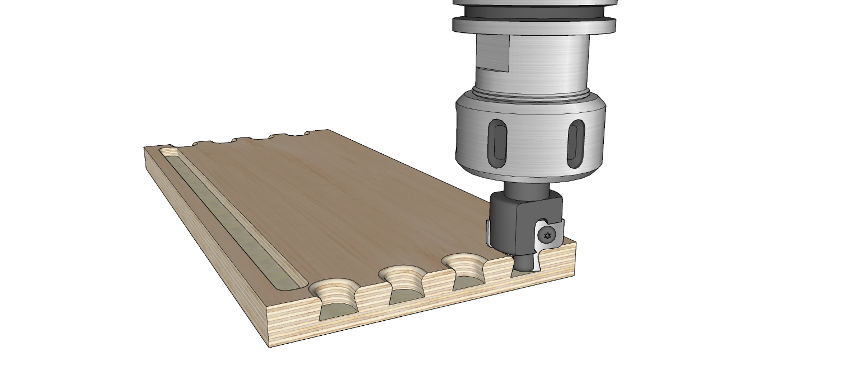Select the tool for the Tail. This tool will be your CNC Dovetail Tool.

**Pin Dimensions**

The pin dimensions are fixed with the standard setups. The depth of the pin is dependent upon the dovetail tool and not the material thickness. The material thickness has no effect on these settings.

**Pin Separation**

Pin separation may be fixed or floating. With the Fixed option selected, the spacing between the centerline of the pins will be set to the fixed distance entered for “Dist”. The pins will be placed along the drawer side such that the space above and below the row of pins is “Balanced” or equalized while maintaining a fixed distance between the pins. With fixed pin separation, for ideal results, standard drawer box heights may need to be used.

With the non-Fixed (Floating) pin separation, the separation between the pins varies between the minimum and maximum distance such that all pins are equally spaced, and the top and bottom pin will be sized like the pins in the row.

**Part Spacing**

*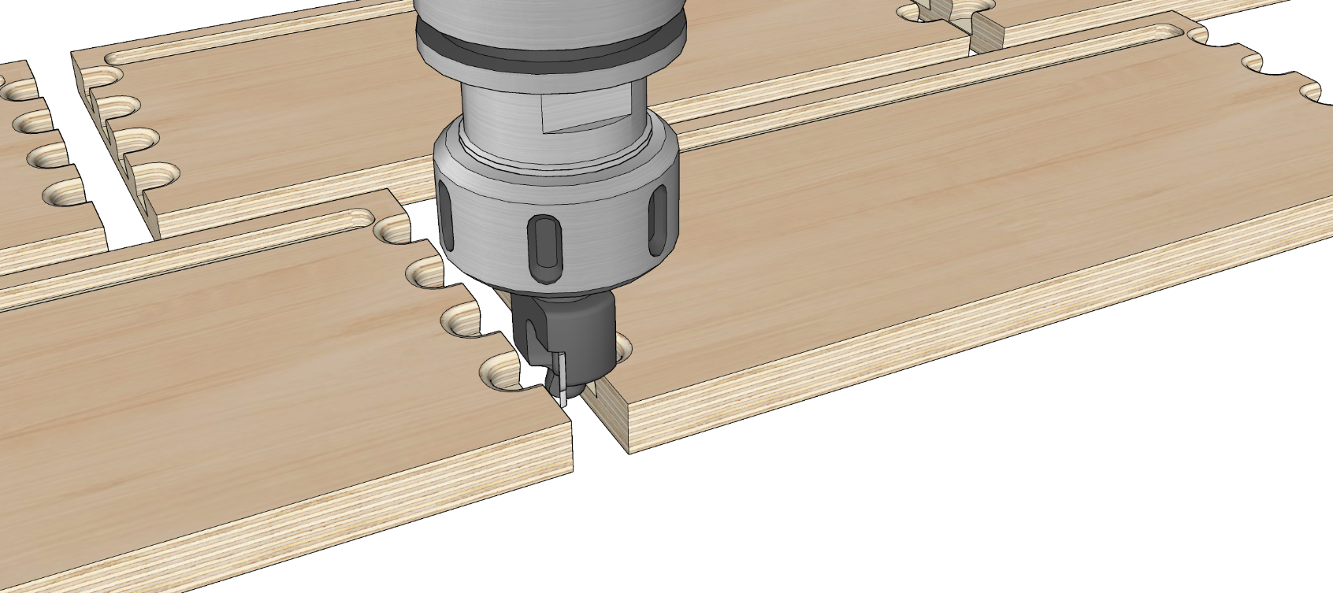The part spacing must be increased when using the dovetail tool. For the Vortex setup, the part spacing must be* ***at least 9/16”*** *for the dovetail tool path.*

**9/16” Minimum**

**Joint Tolerance (Pin Thick)**

By adding a positive number for the Pin tool tolerance, the pin will get thicker by this amount to increase the tightness of the joint.

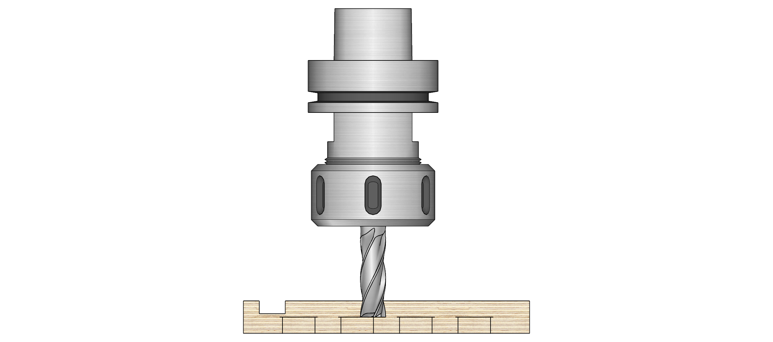

*+*

-

**Joint Tolerance (Tail Length)**

Entering a positive number for the Tail length will make the tail tool travel further into the material. Entering a negative number will make the tool NOT travel as far into the material. If you are getting marks that are visible on the inside of your assembled drawer box, enter a negative adjustment. For best results, start off with a Tail length adjustment of -0.029.”

**Joint Tolerance (Tail Depth)­­**

Entering a positive number for the Tail joint tolerance will make the tail tool plunge deeper and increase the tightness of the joint. If the tail tool plunges too deep and leaves marks on the inside of the drawer side, a negative value may be entered here.

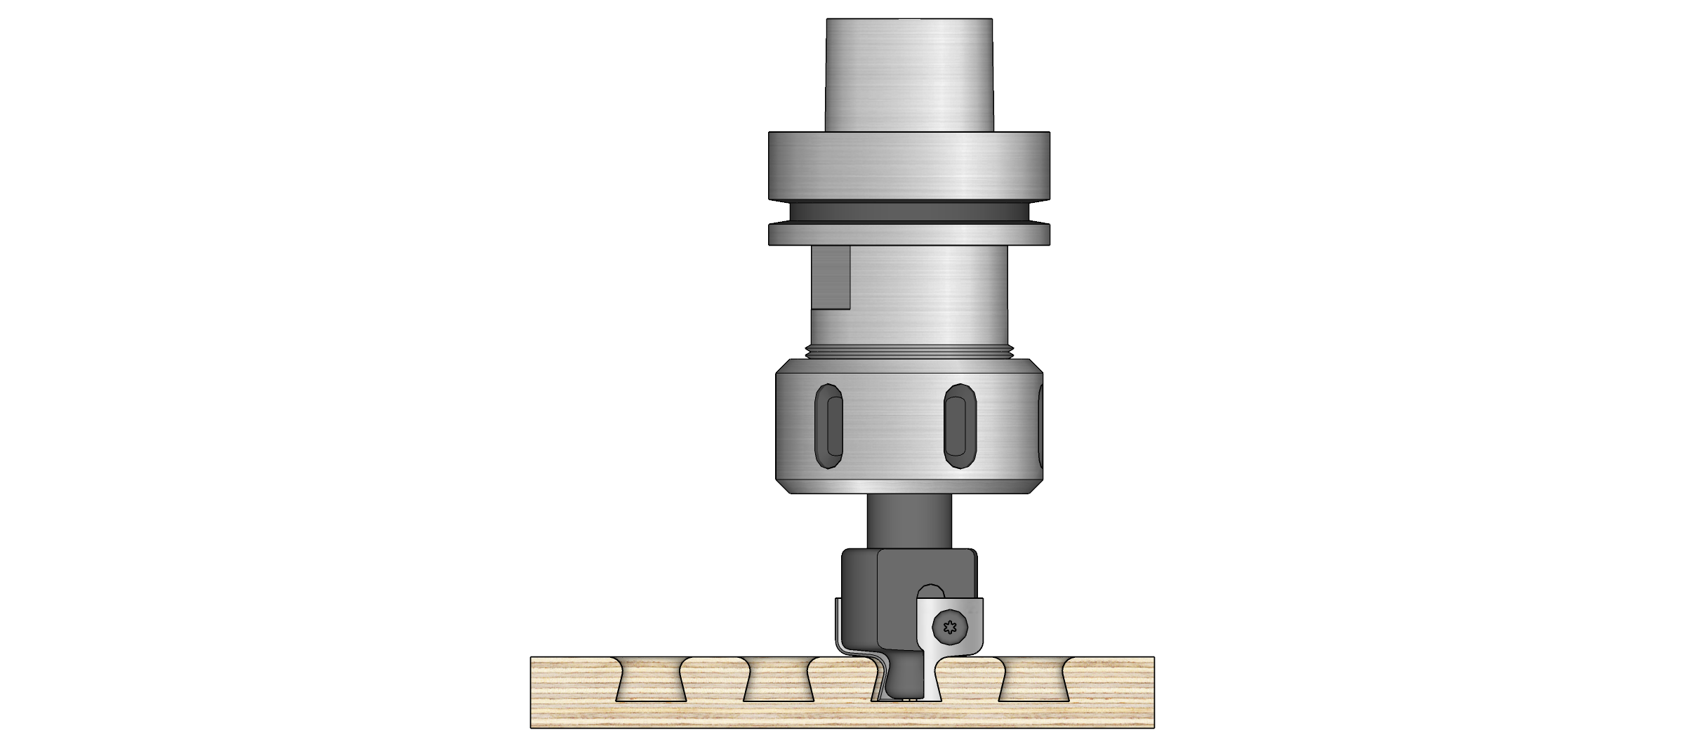

**+**

-

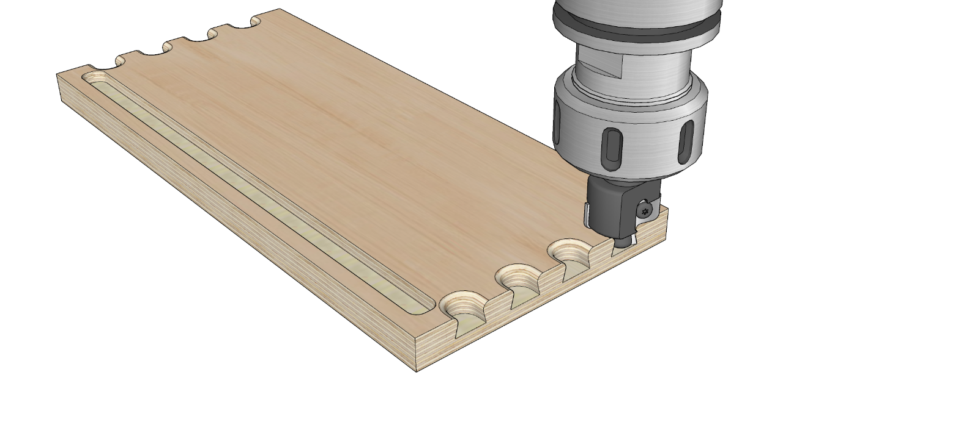

*+*

-

**Tips for Quality Dovetail Drawers**

Dovetail drawers are one of the most demanding parts to produce on the router. There are 4 steps that must be done well to produce ideal results:

1. Enter the **exact thickness** of the material for the drawer materials into the material library.
2. Make sure **spoil board** is well **surfaced** and clean.
3. Ensure **enough vacuum** is available (or screw hold-downs) to make sure parts lay flat.
4. Make sure your **tool length** and **Z Levels** are **properly** set on your CNC machine.